Steven Mathias
7/26/2026
CS 499 Capstone
Module Four

Enhancement Two: Narrative
I chose to perform the second enhancement on the Course Planner C++ program that was originally made for CS 300 Analysis and Design. This program presents the user with a menu to load data from a course list file, and once loaded, print a list of all courses, print a specific course, or exit the program. The program parses each line of the file loaded and stores the Course ID, name and prerequisites. The second category is titled “Algorithms and Data Structures”, I decided to enhance this artifact by upgrading the simple unordered_map to a node based linked list. This demonstrates my ability to work with different data structures, as well as modify existing project architecture while not compromising the original functionality.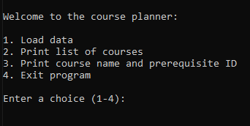
The source code screenshots present a node structure to establish a new node to hold a single course’s information. Then, incorporate pointers to connect all the nodes in a chain, so that the program can then start from the beginning to search for specific data or print in alphanumerical order. Additionally, I included a crucial element to the overall system architecture that deallocates memory in the list. Without this “clearList” function, each time a user selected to load data, the original data would remain in the memory. This data builds up and could result in memory leaks. This could slow the memory and eventually crash the program. By calling clearList(head), we are clearing out the data before loading new data.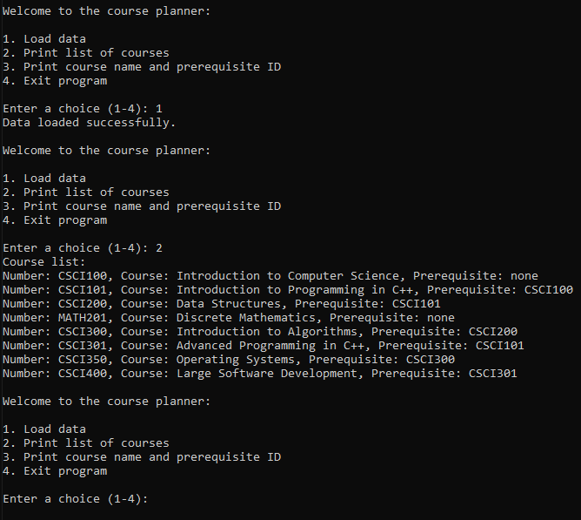
Some of the aspects of the new code include node structure to establish a new node to hold a single course’s information, then incorporating pointers to connect all the nodes in a chain, that the program can then start from the beginning to search for specific data or print in alphanumerical order.
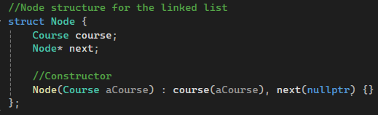
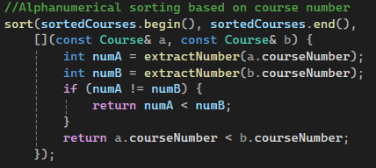
In addition, I included a crucial element to the overall system architecture that deallocates memory in the list. Without this “clearList” function, each time a user selected to load data, the original data would remain in the memory. This data builds up and could result in memory leaks. This could slow the memory and eventually crash the program. By calling clearList(head), we are clearing out the data before loading new data.
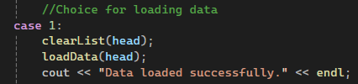
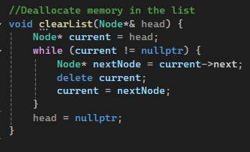

This enhancement required an ability to identify an area for improvement of data structures and design, then build and finalize the improvements. The course outcomes satisfied with this enhancement, specifically identifying and upgrading the unordered_map to a linked list, include demonstrating an ability to use well-founded and innovative techniques, skills, and tools in computing practices for the purpose of implementing computer solutions, as well as the outcome for designing and evaluating computing solutions that solve a given problem using algorithmic principles. Finally, the program excels to accomplish designing, developing, and delivering professional-quality oral, written, and visual communications by adhering to well-crafted comments and readability within the source code.
